13-3_SQL_ Trushkova_Modifying_A_Table

1. Why is it important to be able to modify a table?

Может изменится формат ввода данных, может понадобиться изменить структуру базы данных из-за расширения компании и добавления новых сотрудников из другой базы данных.

1. CREATE a table called Artists.

a. Add the following to the table:

· artist ID

· first name

· last name

· brand name

· email

· hourly rate

· song ID from d_songs table

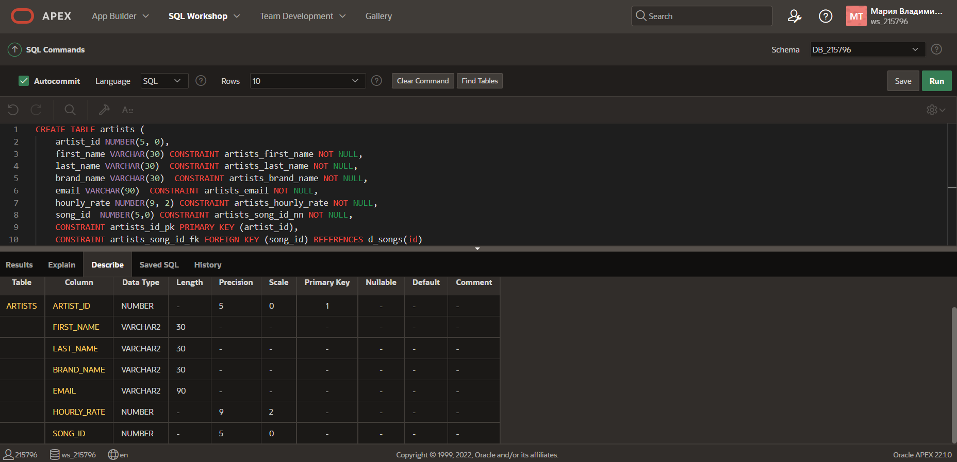

b. INSERT one artist from the d_songs table.

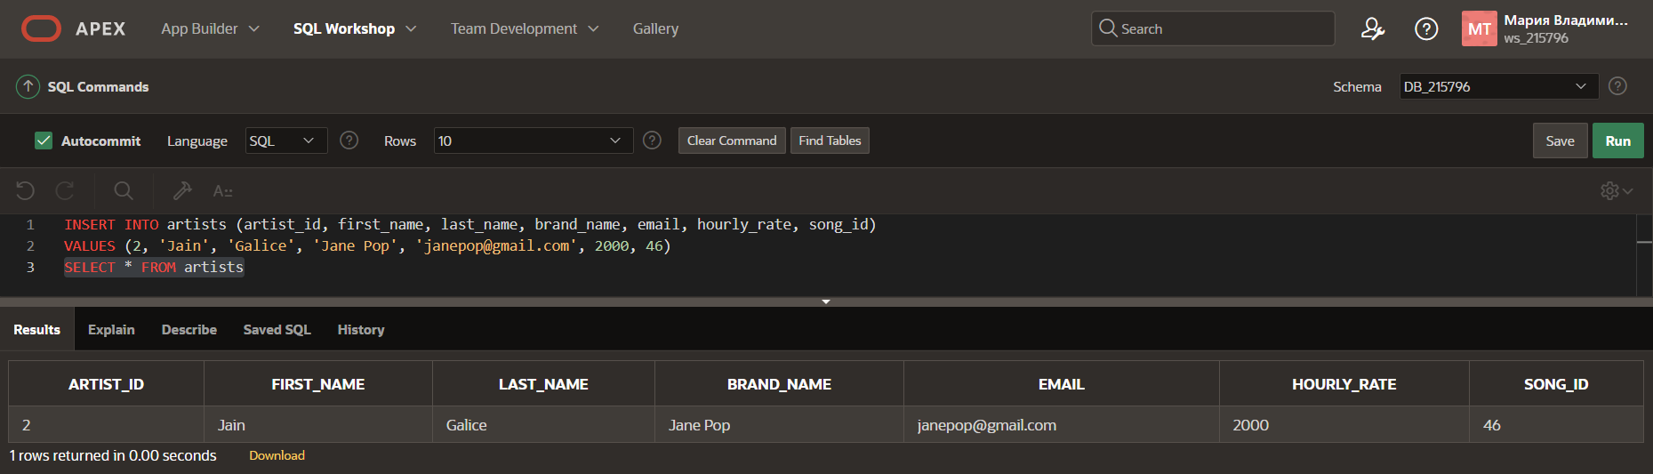

c. INSERT one artist of your own choosing; leave song_id blank

d. Give an example how each of the following may be used on the table that you have created:

1. ALTER TABLE

1. DROP TABLE

3) RENAME TABLE

4) TRUNCATE

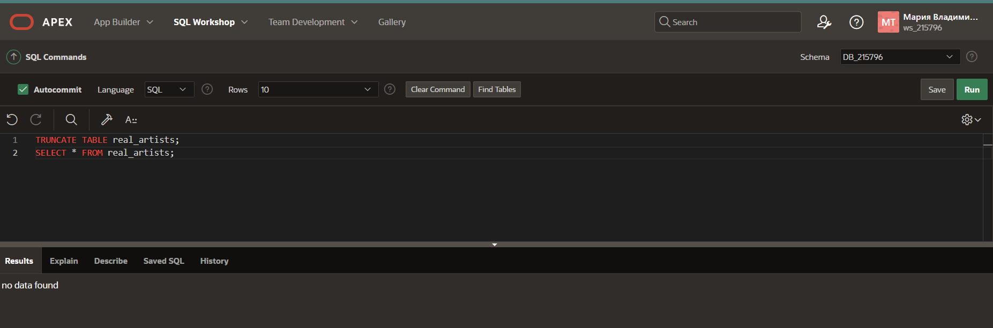

5) COMMENT ON TABLE

